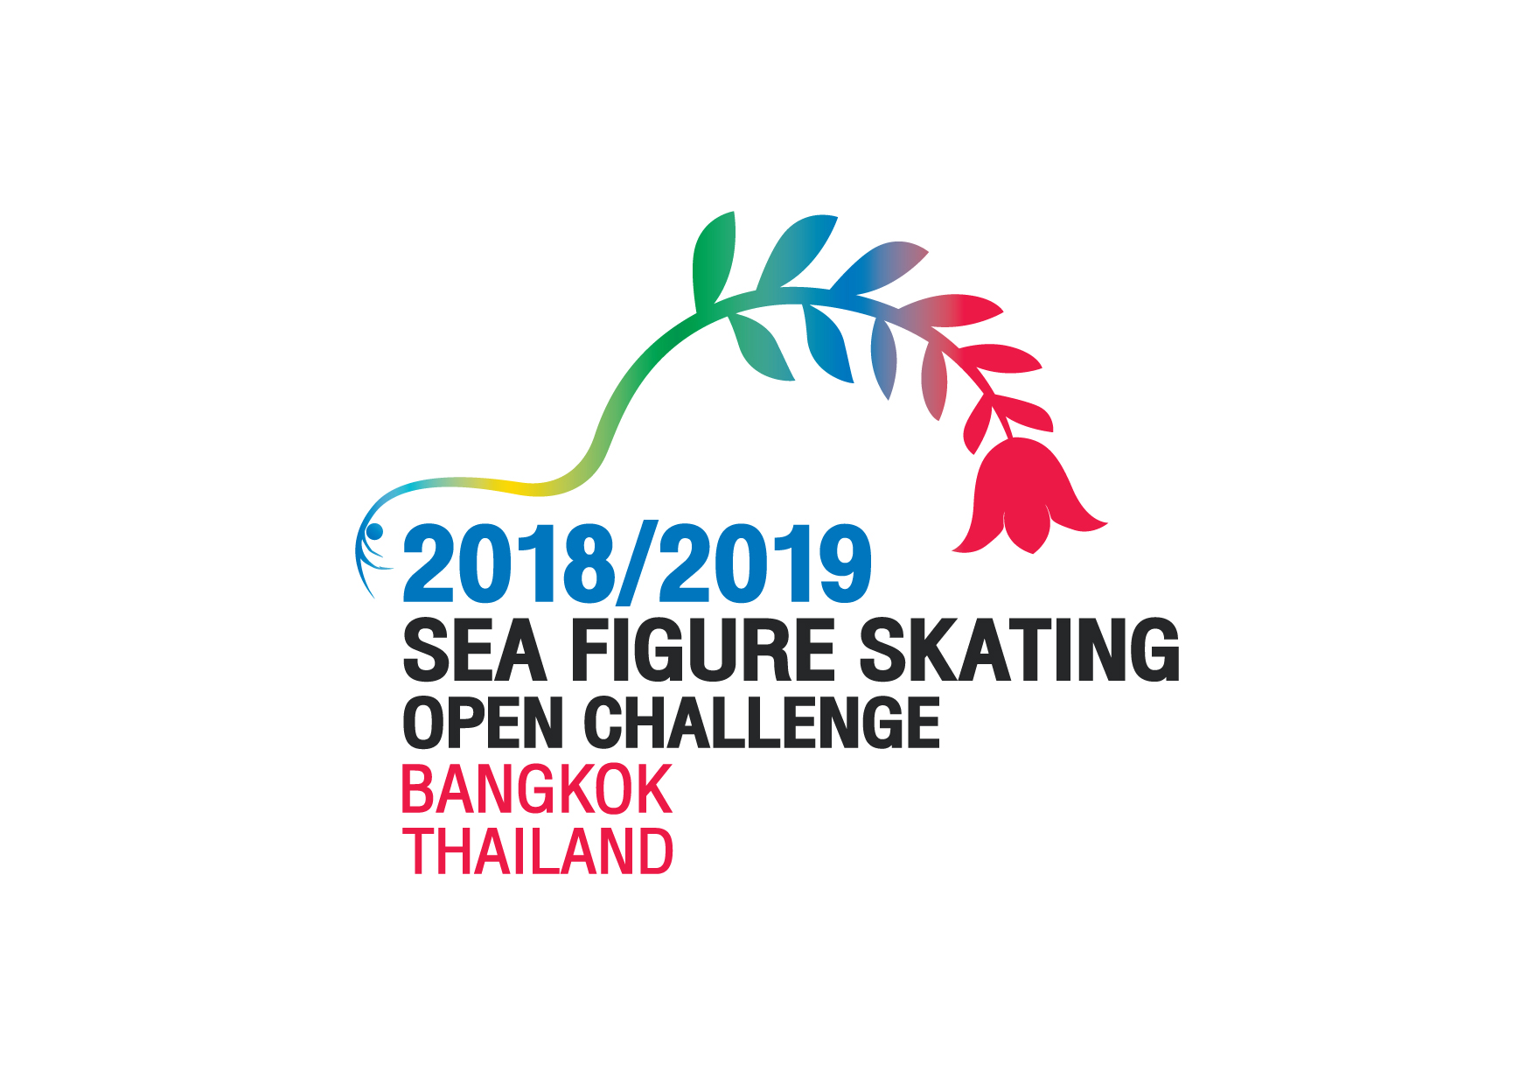
ISU Member : |  |  |  |  |  |  |  |  |  | ISU Abbreviation:
Category: |  | Basic Senior Men  Basic Senior Ladies  Elite Junior Men  Elite Junior Ladies  Basic Junior Men  Basic Junior Ladies |  |  |  | Advanced Novice Boys  Advanced Novice Girls  Intermediate Novice Boys  Intermediate Novice Girls  Basic Novice Boys  Basic Novice Girls |  | Advance Pre-Novice Boys  Advance Pre-Novice Girls  Basic Pre-Novice Boys  Basic Pre-Novice Girls  Advance Juvenile Boys  Advance Juvenile Girls |  |  |  | Basic Juvenile Boys  Basic Juvenile Girls
Competitor(s):
Coach Name:
Short Program or Interpretive Program |  |  |  |  |  |  |  | Year of first performance:
1 | Name of Music :
1 | Composer : |  |  |  |  |  | Duration of Music :
2 | Name of Music :
2 | Composer : |  |  |  |  |  | Duration of Music :
Free Skating |  |  |  |  |  |  |  | Year of first performance:
1 | Name of Music :
1 | Composer : |  |  |  |  |  | Duration of Music :
2 | Name of Music :
2 | Composer : |  |  |  |  |  | Duration of Music :
ISU Member Federation :
Date, Signature :

