I, the undersigned  (full name of Participants) | 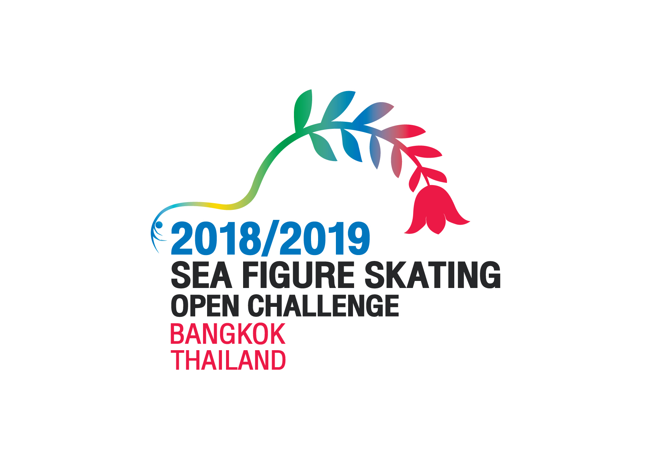
born on (day, month, year )
residing at (full address )
on the occasion of  (name/date of the event) | SEA Figure Skating Open Challenge 2018/2019, Bangkok, Thailand

Hereby make the following declaration and confirm that it is applicable to all of the above-mentioned Participants’ activities, performances, services, rights and responsibilities in the above-mentioned SEA Figure Skating Challenge 2016 (SEA) Event and in all other events and activities conducted under the auspices, sanction or jurisdiction of the SEA. Declarations of Participants who have not reached the age of 18 must be co-signed by at least one of the Competitor’s parents or the Competitor’s lawful guardian.

I/we, the undersigned,
- accept the ISU Constitution, SEA Rules and Requirements in the Event Announcement and recognizes the Court of Arbitration for Sport (CAS), in Lausanne, Switzerland as the arbitration tribunal authorized to issue final and binding awards involving the SEA, its Members and all participants in SEA activities, excluding all recourse to ordinary courts; and

- accept the inclusion of the SEA Event in the television and other media exhibition arrangements, and that the Competitor’s performance(s) and all activity related to the SEA Event, may be filmed, televised, photographed, identified, and otherwise depicted, recorded and further exhibited and distributed Singapore, Malaysia, Philippine, Indonesia, Thailand or worldwide under conditions and for the purposes now or hereafter authorized by the SEA in relation to promoting the Figure and Speed Skating sports; and

- confirm that the Participants entered is eligible to compete/officiate according to ISU Rule, ASU Rules and Members Management Regulations in each related ISU/ASU Member Federations; and

- certify and warrant that for Figure Skating SEA Events the music and choreography presented and used by the Competitor in SEA Events have been fully cleared and authorized for public use and television and other media exhibition broadcast and re-broadcast throughout Singapore, Malaysia, Philippine, Indonesia, Thailand and the world without further clearances or payments of any kind on the part of SEA, the Ice Rink which held the SEA Event or the relevant television network or broadcaster being required; and

V) am familiar with the ISU Code of Ethics as well as ISU Anti-Doping Rules and also with the current List of Prohibited Substances and Methods and I declare that I will fully comply with such Rules.

Participants: | Date: |  | Signature:
Competitor’s parent or lawful guardian  for Competitors who have not reached the age of 18: | Date: |  | Signature:

